Assignment 2

*Name: Muhammad Maaz Khan*

*Class: Se-5B Roll: Se-221053*

*Course:* ***Computer Networks***

*By* ***Sir Wilayat***

***Network Overview***  
**Purpose of the Setup**

The "Router on a Stick" configuration is used to enable communication between multiple VLANs. In this topology:

* **VLAN 10** (192.168.10.0/24): Assigned to devices on Fa0/3 of the switch.
* **VLAN 20** (192.168.20.0/24): Assigned to devices on Fa0/2 of the switch.
* The router (R1) is used for **inter-VLAN routing**, which allows devices in VLAN 10 and VLAN 20 to communicate.

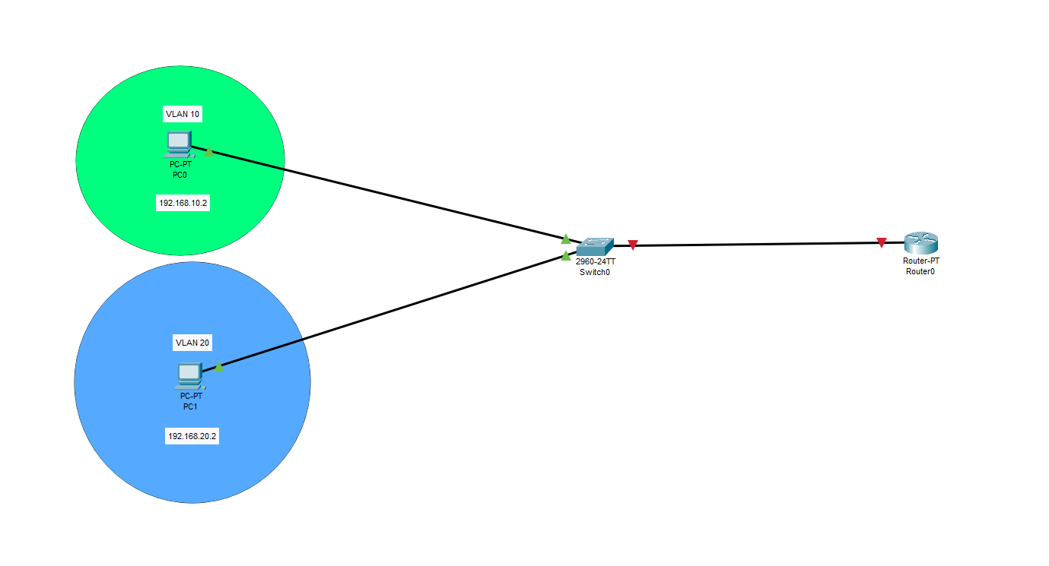

***Switch Configuration***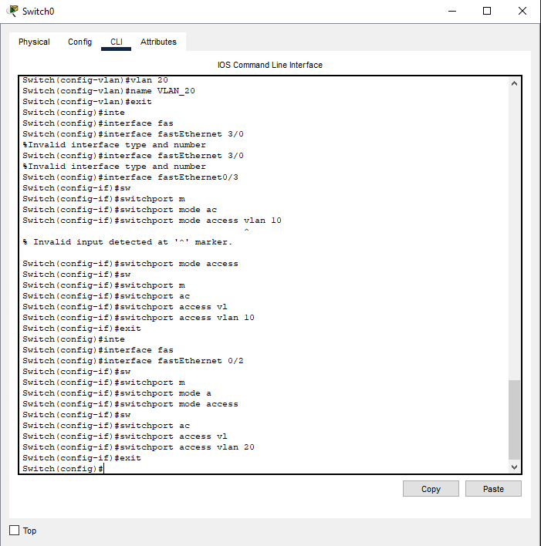 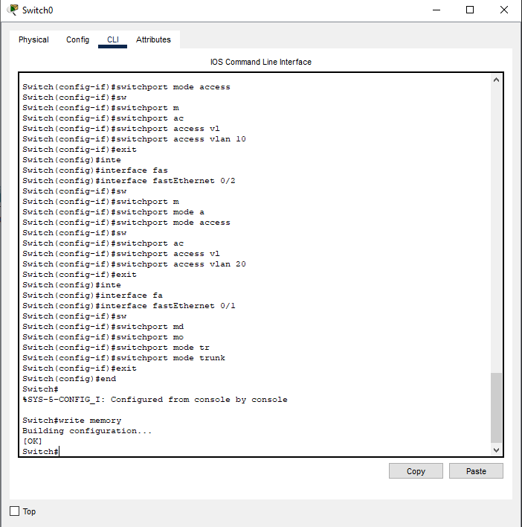  
  
  
  
  
  
  
  
   
  
**VLAN Creation**: VLAN 10 and VLAN 20 are created and named for identification.

**Port Assignment**: Specific switch ports are assigned to their respective VLANs. Devices connected to these ports become part of their respective VLAN.

**Trunk Configuration**: Fa0/1 is configured as a trunk to carry traffic for both VLANs to the router.  
  
  
  
  
  
  
  
  
  
  
  
  
  
  
  
  
  
  
  
  
  
  
***Router Configuration***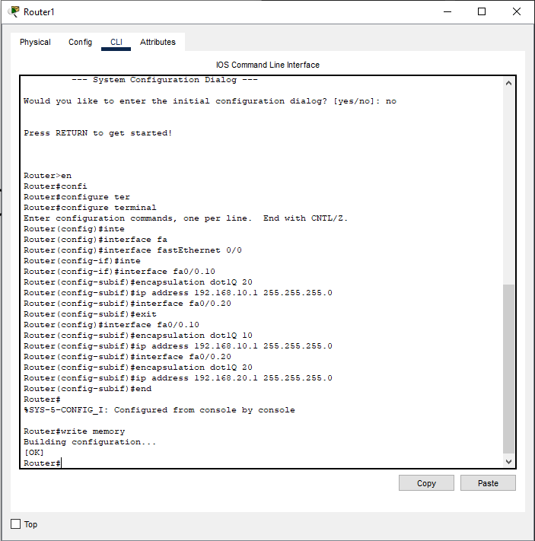**Sub-Interfaces**: These virtual interfaces allow the router to handle traffic for multiple VLANs. Each sub-interface corresponds to a VLAN.

**Encapsulation dot1Q**: Specifies the VLAN ID for each sub-interface and enables 802.1Q encapsulation on the trunk link.

**IP Address**: Each VLAN is assigned a unique IP address, which acts as the default gateway for devices in that VLAN.  
  
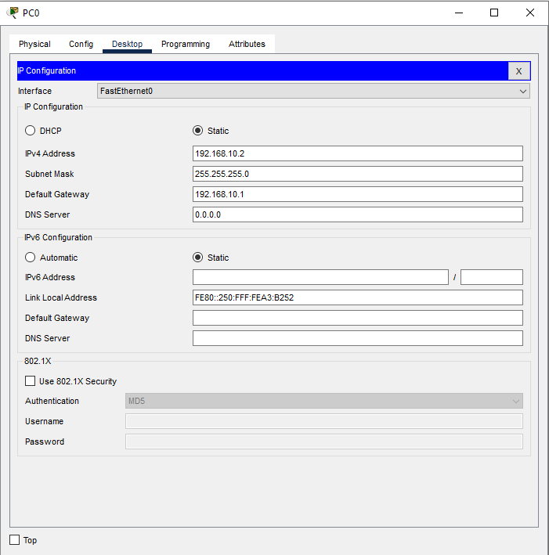  
  
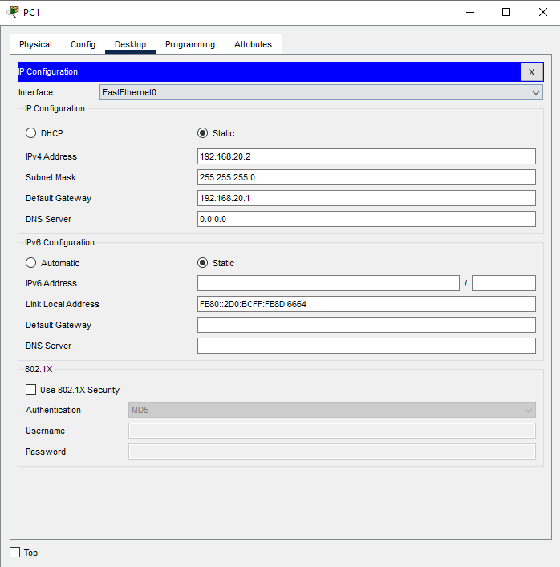  
  
  
 **IP Address**: Each PC gets a unique IP address from its VLAN subnet.

**Subnet Mask**: Defines the subnet range.

1. **Default Gateway**: Points to the router's sub-interface for the VLAN, allowing the PC to communicate with other VLANs.  
     
   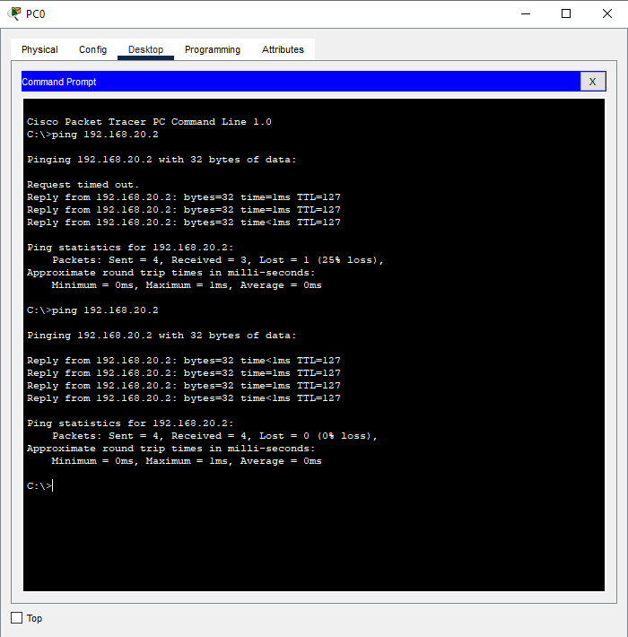  
     
     
     
     
     
     
     
   The router correctly routed the traffic between VLAN 10 and VLAN 20 using its sub-interfaces, confirming that the "Router on a Stick" configuration is working as expected.  
     
     
   For verifications we can use commands like   
     
   **Router**  
   show ip interface brief  
     
   **Switch**  
     
   show vlan brief   
   show interfaces trunk  
     
     
     
     
     
     
     
     
     
     
     
     
     
     
     
     
     
   